Chapter 9, Problem 50.

Determine v_{x} in the circuit shown in Fig. 9.57. Let i_{s}(t) = 5 cos(100t + 40°).

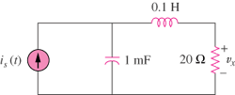

Figure 9.57
For Prob. 9.50.

